Look | Copy | Cover and write
chef
chalet
machine
brochure
chauffer
scheme
chorus
chemist
echo
character
Year 4: Spellings and Handwriting

Strategies to help you learn your spellings:
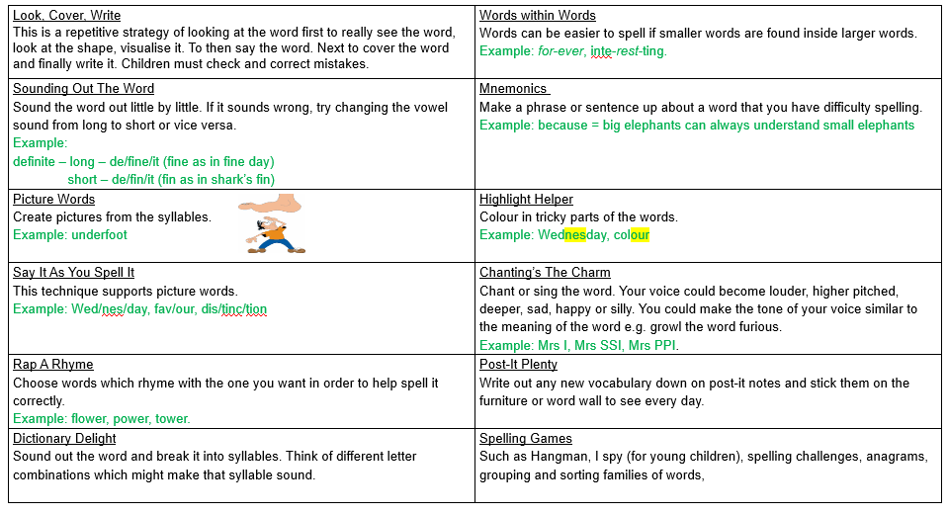

Year 4: Handwriting
Remember to practice your spellings daily and write them neatly into your handwriting book.

Monday | chef | chalet
Challenge: Can you use each of your spellings in a sentence? Record your sentences in your book. Use a dictionary to ensure you understand what each word means!

Tuesday | machine | brochure
Challenge: Can you use each of your spellings in a sentence? Record your sentences in your book. Use a dictionary to ensure you understand what each word means!

Wednesday | chauffer | scheme
Challenge: Can you use each of your spellings in a sentence? Record your sentences in your book. Use a dictionary to ensure you understand what each word means!

Thursday | chorus | chemist
Challenge: Can you use each of your spellings in a sentence? Record your sentences in your book. Use a dictionary to ensure you understand what each word means!

Friday | echo | character
Challenge: Can you use each of your spellings in a sentence? Record your sentences in your book. Use a dictionary to ensure you understand what each word means!

