Week 6 - Year 2 Key Skills
Day 1
LI: To work out addition questions using column method
Task 1- Can you work out these addition questions using the column method?
23 + 46=
15 + 81=
57 + 22=
45+ 11=

Task 2- Work out these addition questions using the column method, but you need to carry the units over.

Watch this video first:
https://www.youtube.com/watch?v=rdzIfqtzPq0

29 + 34=
76 + 25=
43+ 48=
11+ 79=
Week 6- Year 2 Key Skills
Day 2
LI: To know and use adjectives
What is an adjective?
https://www.youtube.com/watch?v=QxoDGlPUmyU
Task 1- Can you circle the adjectives in the sentences below?

That is a beautiful dress!
The forest was spooky and dark.
Suddenly the door opened, and an enormous, hideous giant stood in front of him.
What a fantastic idea.

Task 2- What adjectives can you use to describe the characters below?
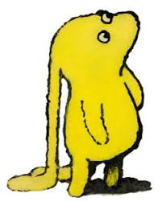

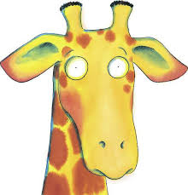

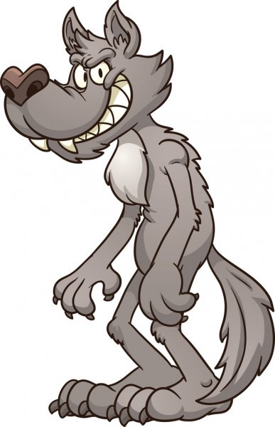
Week 6 - Year 2 Key Skills
Day 3
LI: To use arrays to write multiplication and division sentences
Task 1- Write 2 multiplication and 2 division sentence based on the array.
Example:
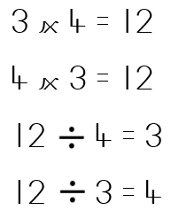

Week 6- Year 2 Key Skills
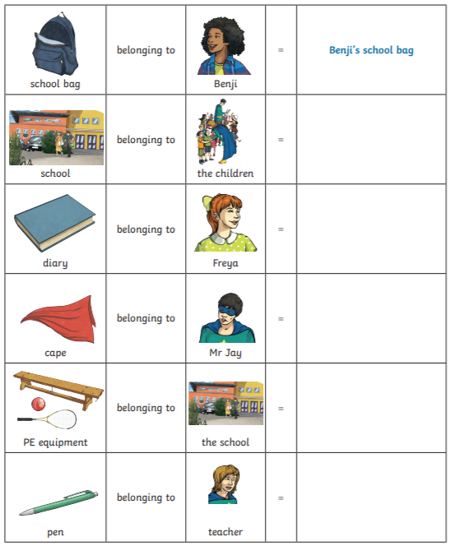
Day 4
LI: To use apostrophe for possession
Task 1: Look at the images and write the phrase saying who the item belongs to. The first one has been done for you.

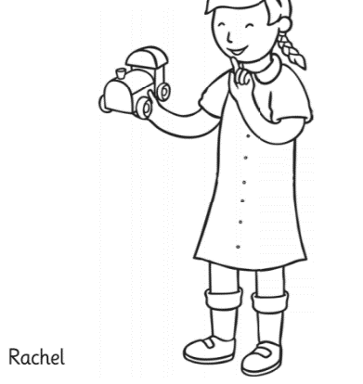
Task 2: Look at the pictures. Can you write a sentence to describe each using an apostrophe to show the possession?
Example:
This is Rachel’s toy train.
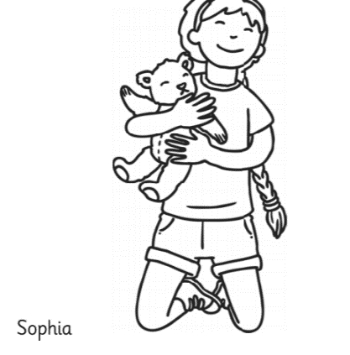
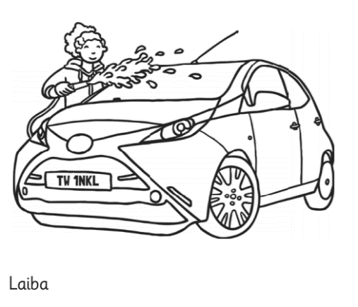
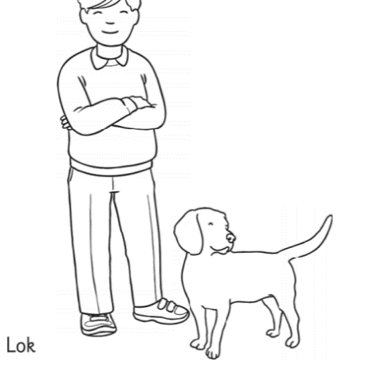
Week 6 - Year 2 Key Skills
Day 5
LI: To find the fractions of different amounts

Task 1-Can you find the fractions to these different amounts?
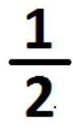
What is a half?

https://www.youtube.com/watch?v=yDhofz3TpEw

How do I find half of a number? - Divide it by 2!
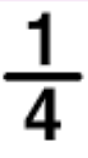
What is a quarter?

https://www.youtube.com/watch?v=3SdRStOBYPo
How do I find quarter of a number? - Divide it by 4!
